1. **INTRODUCTION**

**Project : Intelligent alert system for Tribal people using IBM Watson studio**

* 1. **Overview A brief description about your project**

Tribal people constitute 8.6% of the nation's total population, and most of them spend the greater part of their lives in the proximity of trees and villages or clans near to the forest. There are so many challenges faced by these people out of which Human-wildlife conflict (Human-wildlife conflict refers to the interaction between wild animals and humans, and the resultant negative impact on people, animals, resources, and habitats)  is a serious challenge undermining the protection of tribal regions.

The major types of human-wildlife conflict in the area include crop-raiding, livestock predation, increased risk of livestock diseases, and direct threats to human life. so Active measures are to be implemented to mitigate these problems and safeguard the future of the wildlife. Hence we came up with this  Project “Intelligent Alert System”. This ensures the complete safety of humans who lives near the forests by notifying the wild animal predation before it enters the clan.

1.2 **Purpose The use of this project. What can be achieved using this**

This ensures the complete safety of humans who lives near the forests by notifying the wild animal predation before it enters the clans.

1. **LITERATURE SURVEY**

Monitoring wild animals became easy due to camera trap network, a technique to explore wildlife using automatically triggered camera on the presence of wild animal and yields a large volume of multimedia data. Wild animal detection is a dynamic research field since the last several decades. In this paper, we propose a wild animal detection system to monitor wildlife and detect wild animals from highly cluttered natural images. The data acquired from the camera-trap network comprises of scenes that are highly cluttered that poses a challenge for detection of wild animals bringing about low recognition rates and high false discovery rates. To deal with the issue, we have utilized a camera trap database that provides candidate regions utilizing multilevel graph cut in the spatiotemporal area. The regions are utilized to make a validation stage that recognizes whether animals are present or not in a scene. These features from cluttered images are extracted using Deep Convolutional Neural Network (CNN). We have implemented the system using two prominent CNN models namely VGGNet and ResNet, on standard camera trap database. Finally, the CNN features fed to some of the best in class machine learning techniques for classification. Our outcomes demonstrate that our proposed system is superior compared to existing systems reported in the literature.

**3.THEORITICAL ANALYSIS**

* 1. **Block diagram Diagrammatic overview of the project.**

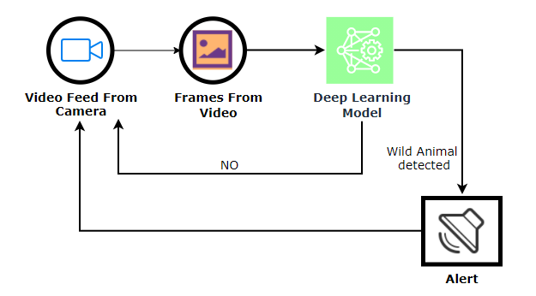

* 1. **Hardware / Software designing**

**. Hardware and software requirements of the project**

1.Installation of Anaconda IDE / Anaconda Navigator.

2.Installation of Python packages.

3.fbprophet

4.spyder/jupyter notebook

5**.**lite account in IBM

**4.EXPERIMENTAL INVESTIGATION**

Made analysis of the given dataset also went through the video deployement in IBM.As this is the guided project given to us went through all the information given to us.

**5.FLOWCHART**

**FLOWCHART Diagram showing the control flow of the solution**

**6.RESULT**

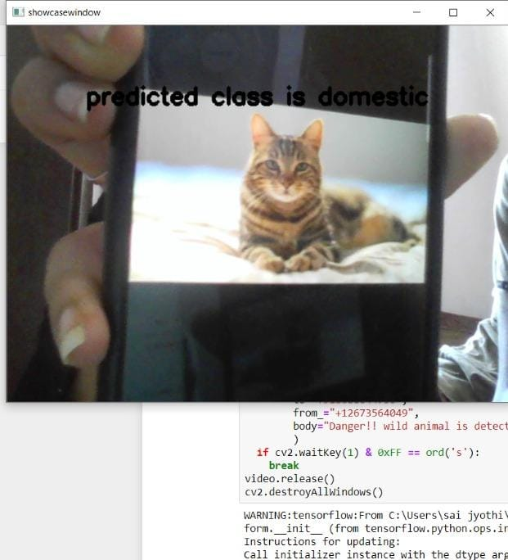

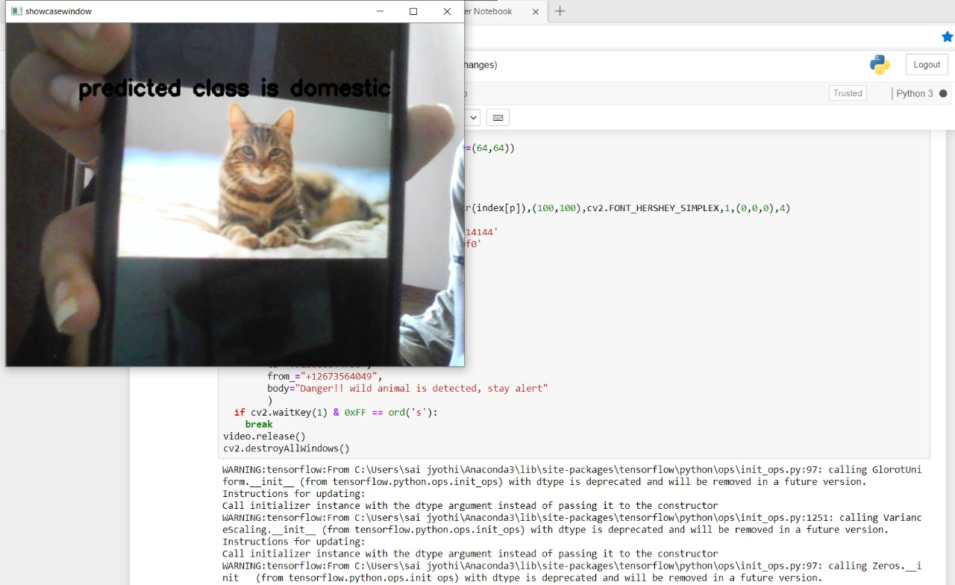

**7. ADVANTAGES &DISADVANTAGES**

**List of advantages and disadvantages of the proposed solution**

**ADVANTAGES:**

* Processes unstructured data.
* Fills human limitations.
* Acts as a decision support system, doesn't replace humans.
* Improves performance + abilities by giving best available data.
* Improve and transform customer service.
* Handle enormous quantities of data.
* Sustainable Competitive advantage**.**

**DISADVANTAGES:**

* Only in English (Limits areas of use)
* Seen as disruptive technology.
* Maintenance.
* Doesn't process structured data directly
* increasing rate of data, with limited resources.

**8. APPLICATION**

This project Intelligent Alert System which ensures safety of humans who live near forest by notifying the people about danger in hand.

**9. CONCLUSION**

Intelligent alert system for forest tribal people model based on neural networks(CNN) incorporated with an alerting system. This system will monitor the entire villages of surrounding forests at regular intervals through a camera . Once any dangerous animal is detected then it will send information to the people in the village by a message alerting them.

**10. FUTURESCOPE**

**.**That can be trained to recognize specific animals in the field.

**.** To recognize elephants, which often come into conflict with humans when they raid crops and enter village.

**.**Can sound an early alarm to help prepare villagers to repel elephants.

**.**In the future, it may also be used to notify biologists of rare or invasive species, stop poachers, or prevent illegal logging.

**11. BIBILOGRAPHY**

**Refered:**

<https://towardsdatascience.com/a-comprehensive-guide-to-convolutional-neural-networks-the-eli5-way-3bd2b1164a53>

**APPENDIX**

**A. Source Code**